1. **Install git.**
2. **Create a repo in GitHub with README.md and .ignore file.**

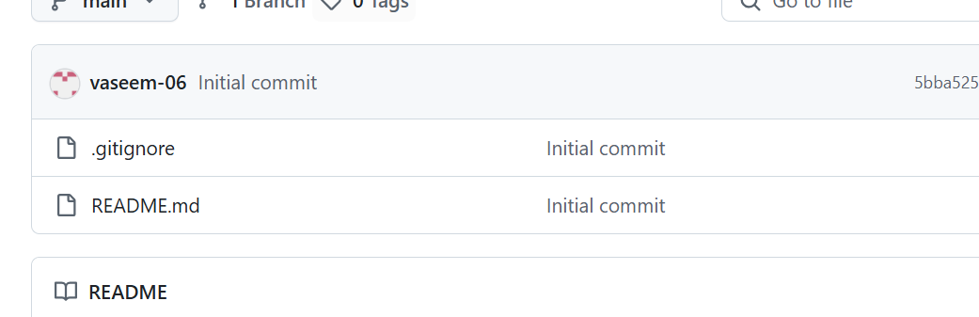

1. **Clone the created repo to local.**

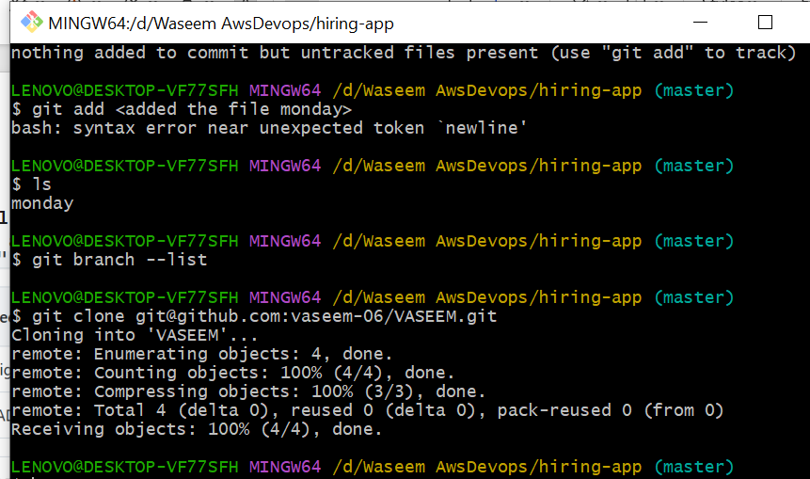

1. **Create two files in local repo.**

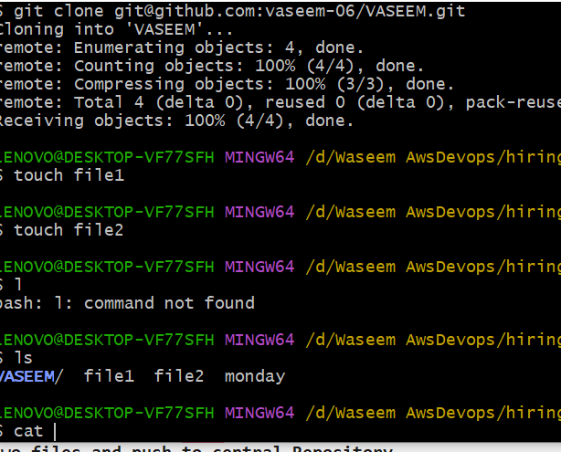

1. **Commit two files and push to central Repository.**

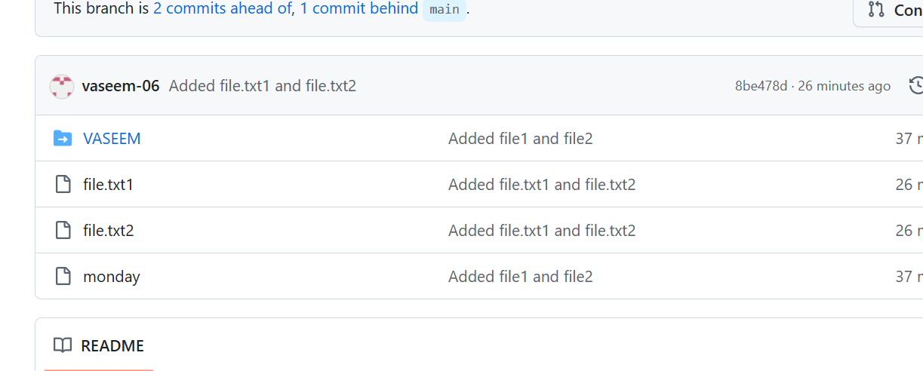

1. **Create a branch in local and create a sample file and push to central**

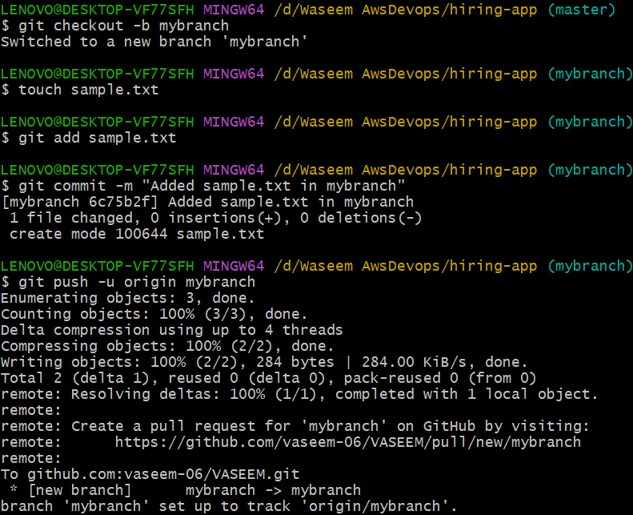

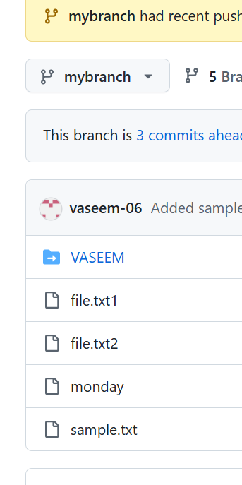

1. **Create a branch in GitHub and clone that to local**

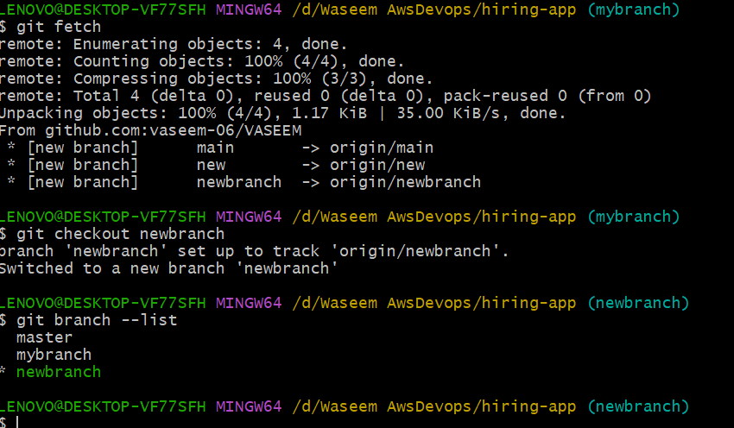

1. **Merge the created branch with master in git local.**

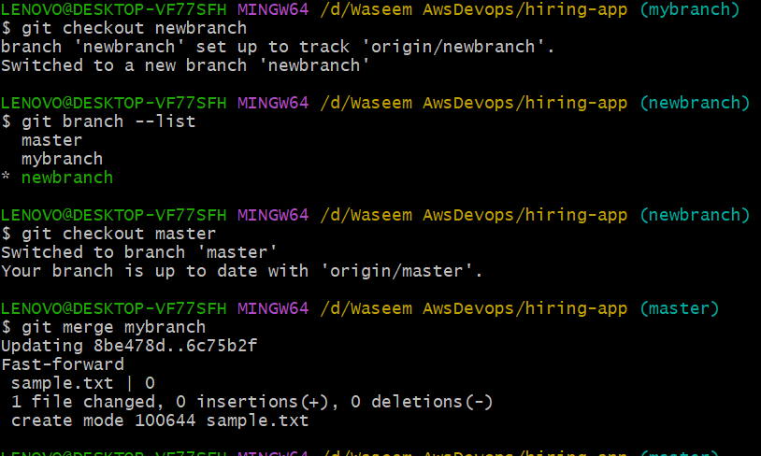

1. **Merge the created branch with master in GitHub by sending a pull request**

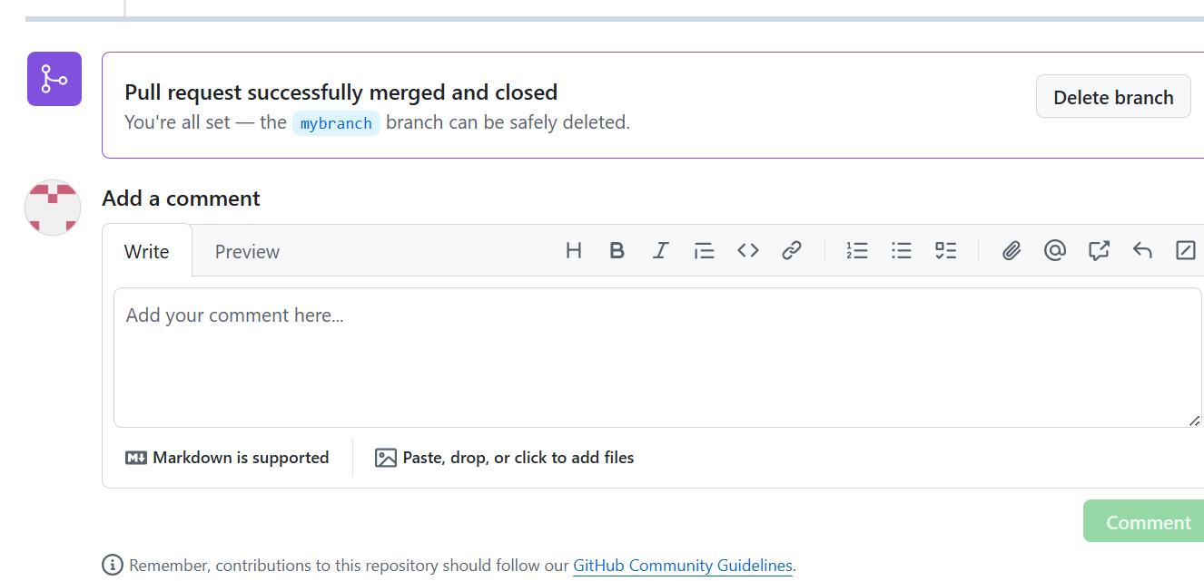

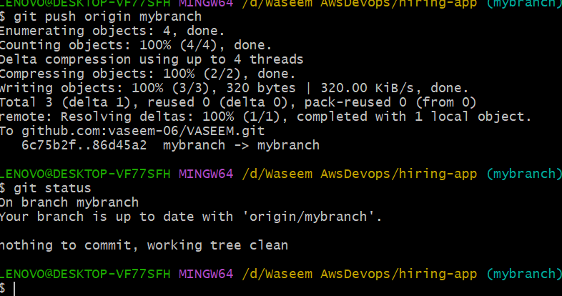

1. **create a file in local and send that to branch in GitHub.**

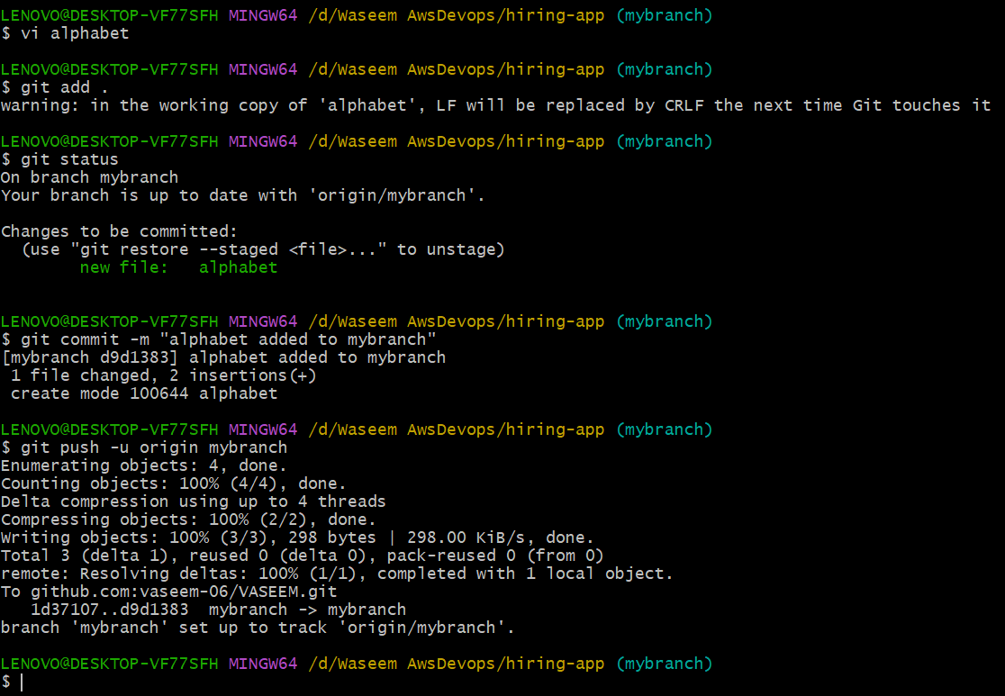

1. **clone only a branch from GitHub to local.**

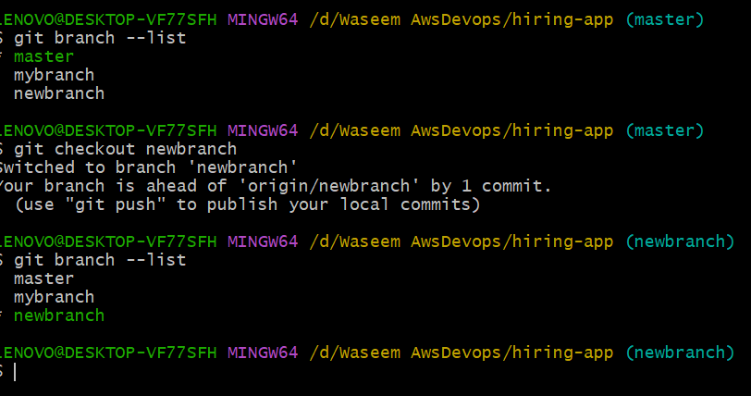

1. **create a file with all passwords and make that untrackable with git.**

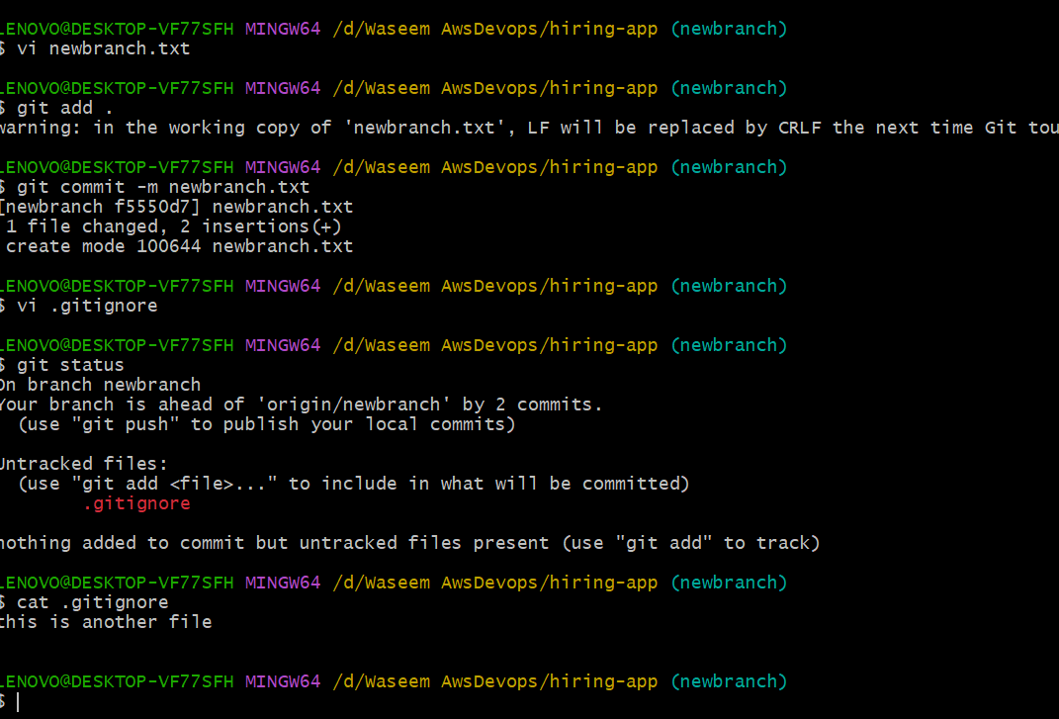

1. **make a commit and make that commit reset without savings changes.**

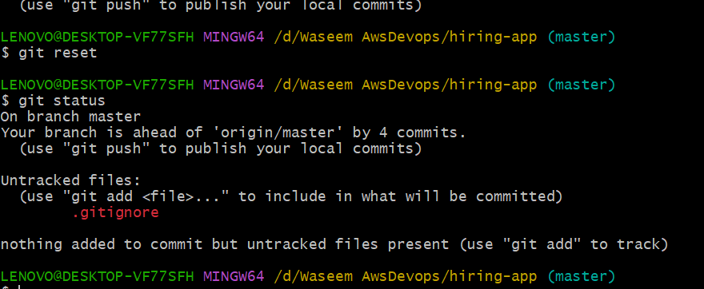

1. **Revert a committed commit to the older version**

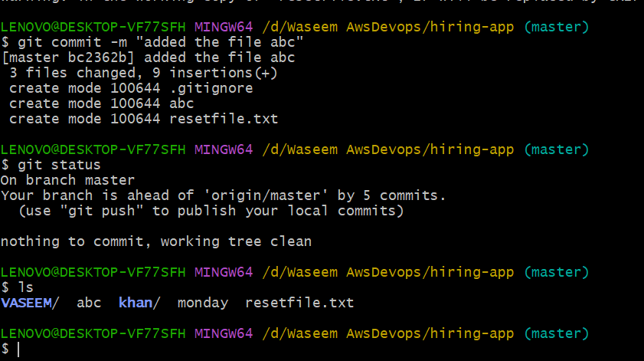

1. **push a file to stash without savings the changes and work on another file.**

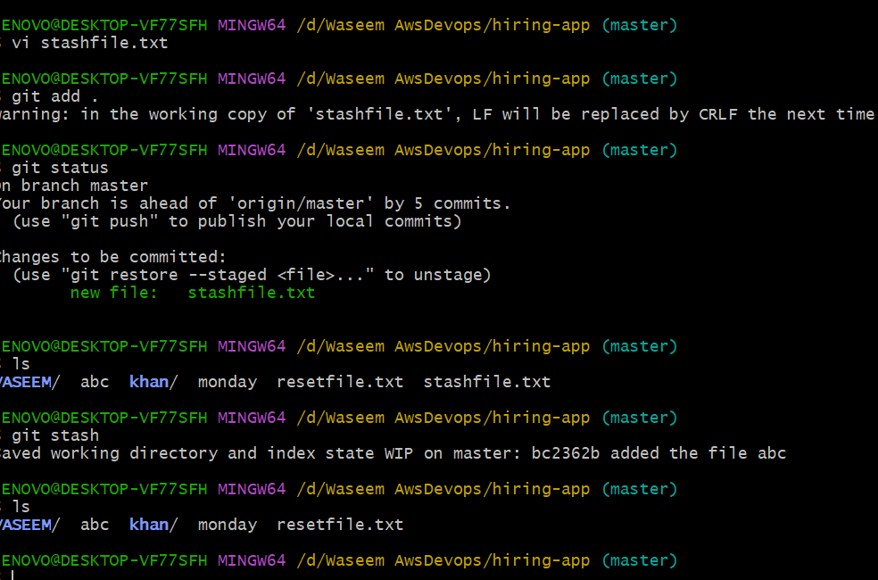

1. **undo the stash file and start working on that again**

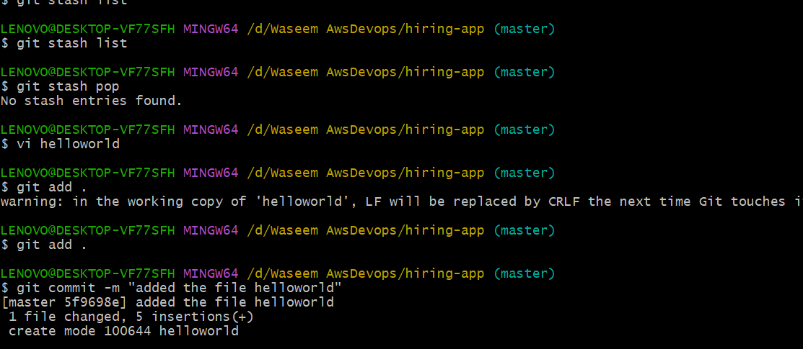

1. **generate a ssh-keygen and configure into GitHub.**

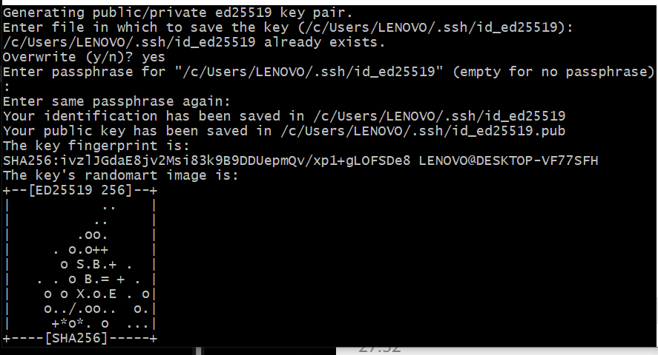

1. **configure web-hooks to GitHub.**

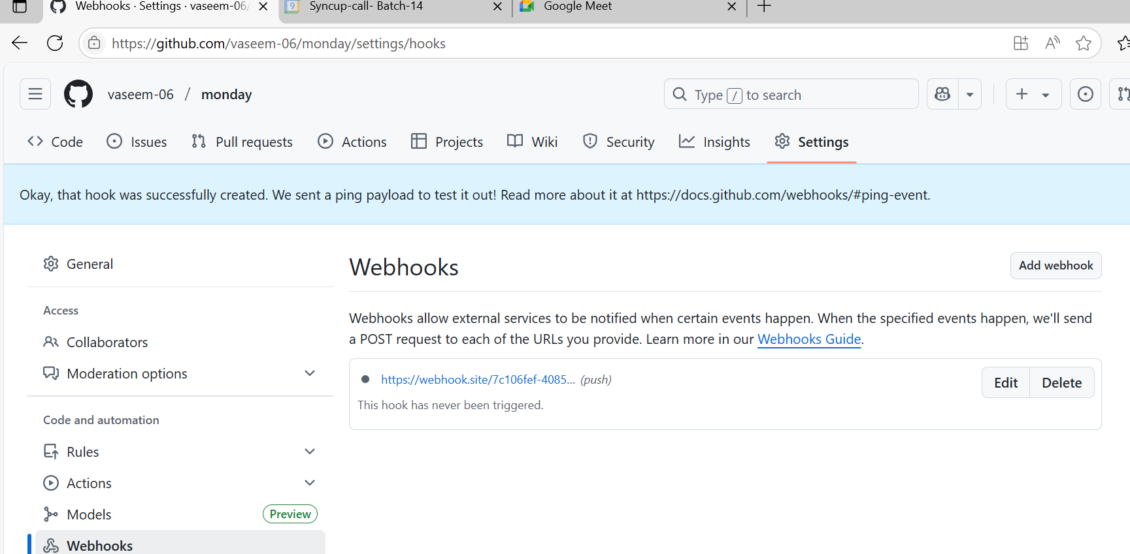

1. **basic understanding of .git file.**

**> When we initiates using git init**

**>It preparesa a directory to track changes within git**

**> Created a hidden git directory in the project**

1. **Check all the logs of git.**

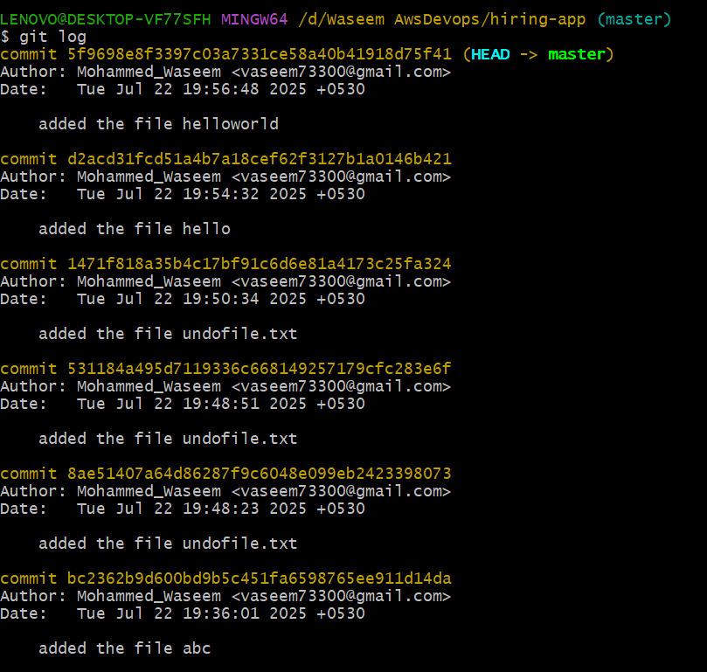

1. **Rename the commit message**

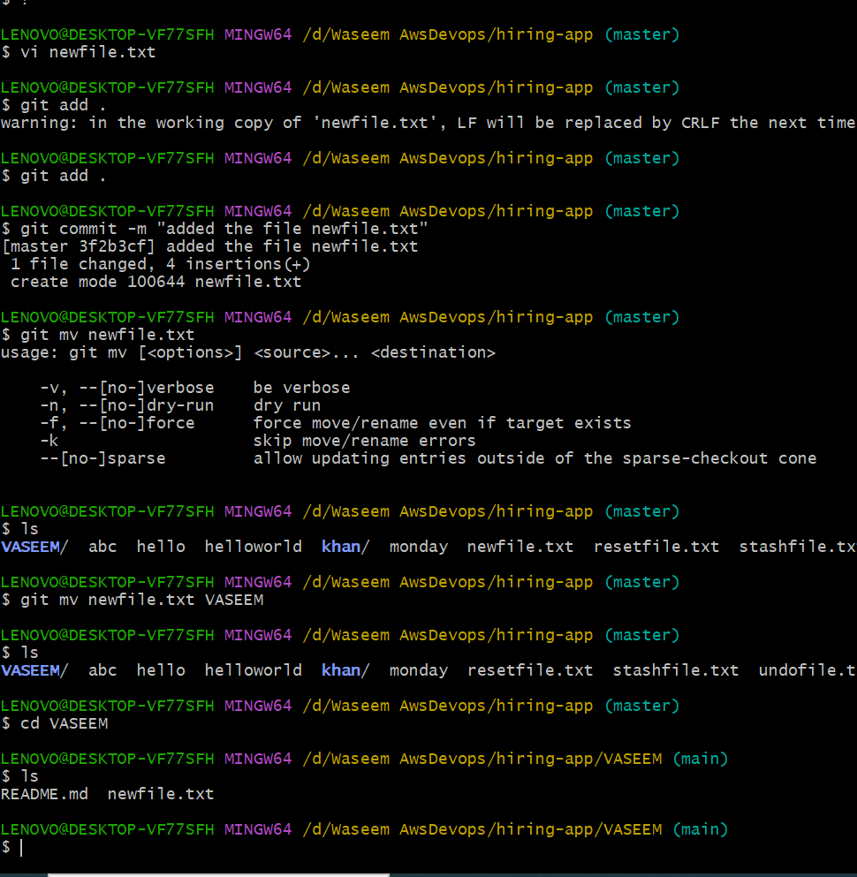

1. **Merge multiple commits into single commit.**

